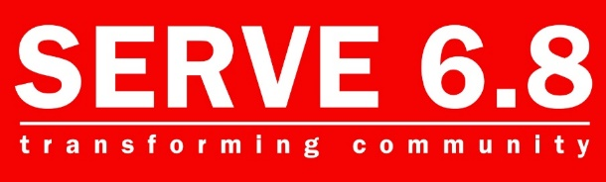
Provided by:
The Talent Ministry
SERVE 68 Resource Center | 1239 E. Drake Rd | Fort Collins, CO | SERVE68.org/Talents

April 13, 2020
Adapted from Jessica Dickler article; Here’s who is hiring right now, amid a bleak jobs picture.

Employment Resources

The coaches from the Talent Ministry know the job market is looking grim right now. With many non-essential businesses forced to close, workers across the country are suddenly facing extended furloughs or lay-offs. There is no avoiding a substantial rise in the unemployment rate over the next few months.

The real unanswerable question at this point is how many of these jobs come back after social distancing guidelines are relaxed and businesses reopen. Amid the coronavirus pandemic, there is a demand for people on the frontlines, particularly in health and online retail.

There is hope. Laid-off workers should look to industries in which the pandemic has placed increased demand for workers, like health care, delivery services, supermarkets and hardware stores, which are open.

Please review the information which we’ve made available that will assist you in your job seeking efforts, located at the Talent Ministry tab

Job Search Sites:

Please refer back to the Employment Resources section for more helpful information. Each time we discover a new website offering jobs opportunities we will let you know. The newest ones are listed at the top of the list below. Remember – DO NOT GIVE UP!

Flexjobs.com
They specialize in work-from-home and remote jobs around the country.

Colorado Job Postings (variety)
https://www.connectingcolorado.com/

themuse.com

LinkedIn.com

Ziprecruiter.com

Glassdoor.com

Indeed.com

AndrewHudson.com

Simplyhired.com

CareerBliss.com

Companies Hiring:
Health care

Hardware stores

Grocery stores

Delivery drivers

Restaurant delivery drivers

Grub hub and those types of companies

SERVE 68 Talent Ministry
We Help with Your Employment Needs

SERVE 6.8 Talents Ministry focuses on helping connect people to open positions within our community and working together to help create a resume that best reflects your skills, strengths, and assets.
Although working together face-to-face is on hold right now, we are here to help you find connection, prayer, financial resource, crisis navigation and more.
We want to reassure you once the Coronavirus crisis is over; coaches will be in place and eager to help you navigate your job search.
Please refer to Resume Helps in your packet for help building your resume.

