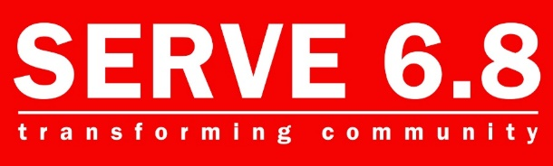
Provided by:
The Talent Ministry
SERVE68 Resource Center | 1239 E. Drake Rd | Fort Collins, CO | SERVE68.org/Talents

Harvard Business Review
Adapted from: 7 Questions to Raise Immediately After You’re Laid Off
Susan Peppercorn

What to do if you are Laid Off or know it’s Coming
Q: When will I receive my last paycheck? Will I get paid for my unused vacation time?
One of the first things you should do if you’re worried about losing your job (or have already lost it) is to know where you stand financially. If you still have your job, double down on your short-term savings plan. Scrutinize your spending to avoid unnecessary purchases; trim memberships and services that you can live without.
If you’ve been laid off,
- Find out when you’ll receive your last paycheck and what it will include.
- Verify details on benefits with HR, such as whether you will get paid out for unused vacation time.
It’s also imperative to apply for unemployment insurance as soon as possible; knowing the amount you are eligible to receive will provide a clearer picture of your finances.

Q: Will I receive severance pay?

Severance packages can come in several forms, including an extension of healthcare benefits and/or career transitions services, but they usually consist of a one-time lump sum paid to employees after their last day of employment. No federal laws currently require businesses to offer severance pay to terminated employees.
Receiving a lump-sum severance payment can feel like a windfall, but it can quickly disappear without a plan. Draw up a monthly budget and ask yourself these questions:
- How long could it take to get another similar paying job?
- Do I have enough to pay my mortgage and other debts for several months?
Before your layoff:
If a layoff has impacted you, don’t assume that you can’t ask for more severance than the company is offering as its standard package, especially when it pertains to ancillary services such as career transition consulting. It’s in the best interest of your employer to maintain a positive relationship with you and build employee loyalty, particularly if the company wants to keep the option open to hire you back in the future.

Q: Is the company offering healthcare coverage after my last day of work, and for how long?
The terms of your employer’s health plan and contract with their health insurer or third-party administrator will determine whether active employee healthcare coverage can continue during a layoff or short-term leave of absence.
- Ask HR what type of coverage your employer will provide, for how long, and what the costs will be to you.
Q: Will you provide a reference for me?
While you may not be thinking about obtaining references from your current employer when you first learn that you’ve been laid off, it’s vital to explore this topic with your boss as soon as possible.
Prospective employers will want to speak directly with your references before extending an offer to you, so be sure to line up your recommenders before your last day on the job if possible. (Keep in mind that most employers prefer a conversation with your references over a written letter.)
Another proactive step is to make sure that you have the collected contact information for managers and colleagues from your current company from whom you plan to request references. If you have a LinkedIn account, send these key connections an invitation to join your network on the site so that you can stay in touch.
Q: How can I get copies of my performance reviews and by when?
If you haven’t saved copies of your previous performance reviews, ask your employer to send them to you before your last day. Having concrete examples of your accomplishments and words of affirmation from your manager in writing will provide invaluable details that you can draw on when updating your resume and LinkedIn profile.
Other Resources

SERVE 68 Ministries are here to help.
https://serve68.org/coronavirus-response/
- Financial Assistance
- Food
- Employment Guidance
- Clothing
- Prayer, Care, and Wellness

Your Local Home Church
- Spiritual Care
- Financial Assistance
- Food
- Clothing

